Experiment No. 4

**Aim: To Study Different Constraints in Oracle.**

* NOT NULL AND PRIMARY KEY CONSTRAINTS

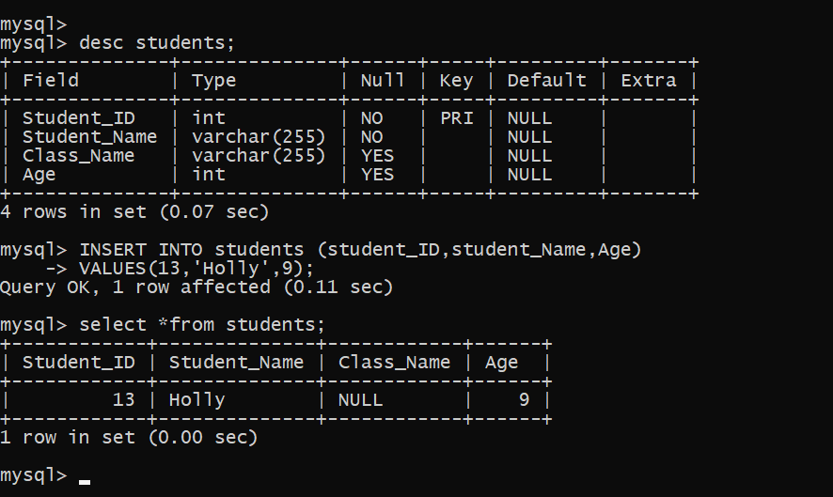

CHECK CONSTRAINT

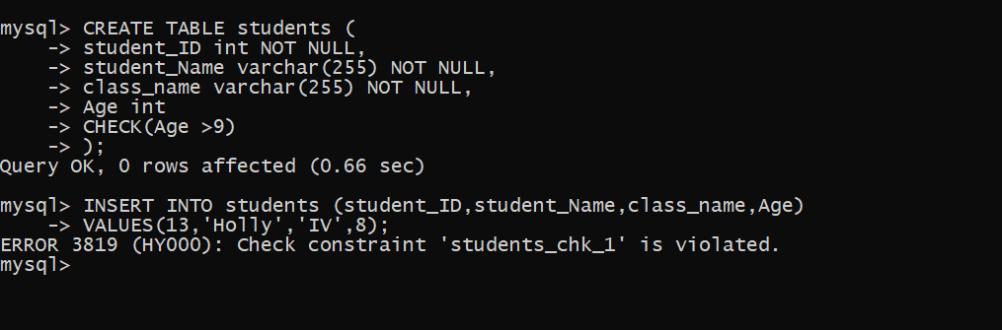

* DEFAULT CONSTRAINT

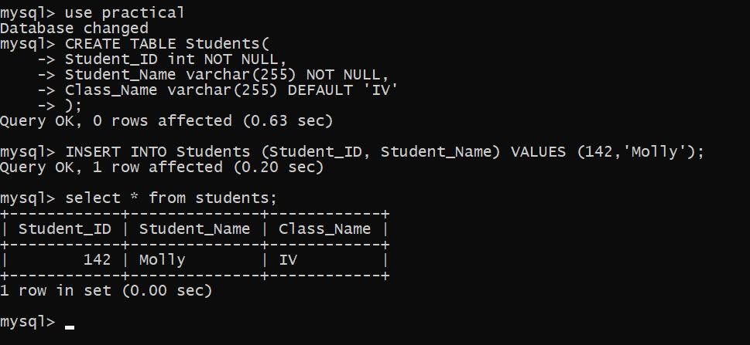

UNIQUE KEY CONSTRAINT

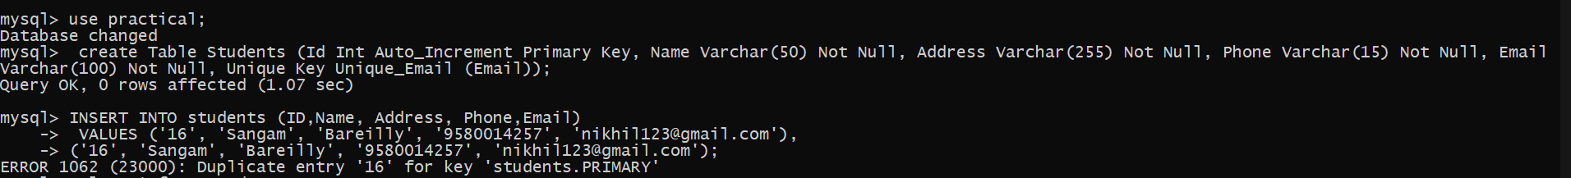

**QUESTIONS**

